SNAPLET.AI - MINI APPLICATION DEVELOPMENT PLATFORM

A project report submitted to the

DEPARTMENT OF COMPUTER APPLICATIONS

in partial fulfillment of the requirements
for the award of the degree of

MASTER OF COMPUTER APPLICATIONS

By

RAHUL PRASANNA N

(REG. NO. RA2432241010315)

Under the guidance of


Dr. G. ELAVARASI M.Sc., M.Phil., Ph.D.,

SRM INSTITUTE OF SCIENCE AND TECHNOLOGY
Faculty of Science and Humanities

Kattankulathur – 603203
Chennai, Tamil Nadu.

APRIL – 2026

BONAFIDE CERTIFICATE

This is to certify that the project report titled “SNAPLET.AI-MINI APPLICATION DEVELOPMENT PLATFORM” is a bonafide work carried out by RAHUL PRASANNA N (RA2432241010315) under my supervision for the award of the Degree of Master of Computer Applications. To my knowledge the work reported herein is the original work done by this student.

Dr. G Elavarasi

Assistant Professor,
Department of Computer Applications
(GUIDE)

Dr. P J Arul Leena Rose

Professor & Head,
Department of Computer Applications

INTERNAL EXAMINER EXTERNAL EXAMINER

DECLARATION OF ASSOCIATION OF RESEARCH PROJECT WITH SUSTAINABLE DEVELOPMENT GOALS

This is to certify that the research project entitled “SNAPLET.AI- MINI APPLICATION DEVELOPMENT PLATFORM” carried out by Mr. RAHUL PRASANNA N under the supervision of Dr. G. Elavarasi in partial fulfilment of the requirement for the award of Post-Graduation program has been significantly or potentially associated with SDG Goal No 09 (NINE) titled INDUSTRY, INNOVATION and INFRASTRUCTURE

This study has clearly shown the extent to which its goals and objectives have been met in terms of filling the research gaps, identifying needs, resolving problems, and developing innovative solutions locally for achieving the above-mentioned SDG on a National and/or on an international level.

SIGNATURE OF THE STUDENT GUIDE

HEAD OF THE DEPARTMENT

ACKNOWLEDGEMENT

With profound gratitude to the ALMIGHTY, I take this chance to thank people who helped me to complete this project.
I take this as a right opportunity to say THANKS to my parents who are there to stand with me always with the words “YOU CAN”.
I wish to express my sincere gratitude to Dr.T.R. Paarivendhar, Chancellor, SRM Institute of Science & Technology who gave us the platform to establish me to reach greater heights.
I am thankful to Prof. A.Vinay Kumar, Pro Vice-Chancellor (SBL) and Dr. A.Duraisamy, Dean, Faculty of Science and Humanities, SRM Institute of Science & Technology for their unwavering support throughout my project.
I earnestly thank Dr. S. Albert Antony Raj, Professor and Deputy Dean, College of Sciences, Faculty of Science and Humanities who always encourage me to do novel things.
I express my sincere thanks to Dr. P. J. Arul Leena Rose, Professor and Head, Department of Computer Applications, Faculty of Science and Humanities for her valuable guidance and support to execute all incline in learning.
It is my delight to thank my project guide Dr. G. Elavarasi, Assistant Professor, Department of Computer Applications for her help, support, encouragement, suggestions, and guidance throughout the development phases of the project.
I convey my gratitude to all the faculty members of the department who extended their support through valuable comments and suggestions during the reviews.
A great note of gratitude to friends and people who are known and unknown to me who helped in carrying out this project work a successful one.
RAHUL PRASANNA N

PLAGIARISM REPORT

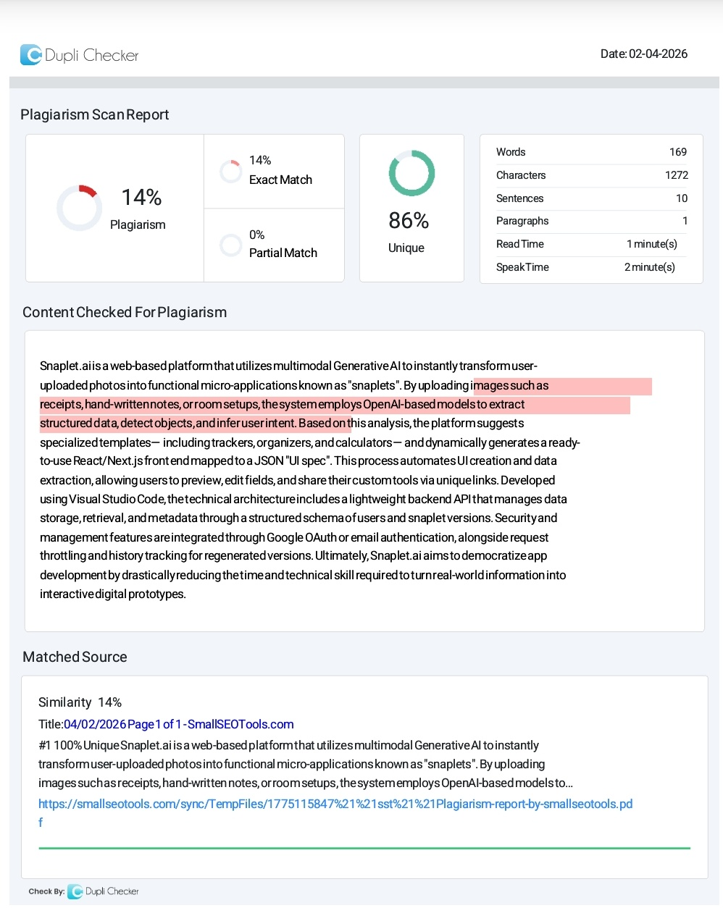
TABLE OF CONTENTS
- INTRODUCTION 1
- LITERATURE STUDY……………………………………………… 5
  - EVOLUTION OF MULTIMODAL AI AND VISUAL REASONING………………..............................................................6
  - GENERATIVE UI (GENUI) AND DECLARATIVE FRAMEWORKS…………………………………………………… 8
  - THE RISE OF MICRO-APPLICATIONS AND CITIZEN DEVELOPERS…………....................................................................8
  - SECURITY AND AGENTIC AUTOMATION……………………………………………………..9
- SOFTWARE REQUIREMENT ANALYSIS………………………....11
  - HARDWARE SPECIFICATION…………………………………....11
  - SOFTWARE SPECIFICATION………………………………....…..11
  - ABOUT THE SOFTWARE AND ITS FEATURES………………...11
- SYSTEM ANALYSIS……………………………………………….......13
  - REQUIREMENT SPECIFICATION…………………………….…..13
  - CHARACTERISTICS OF EXISTING SYSTEM……………….…..14
  - FEASIBILITY STUDY………………………………………….…..15
  - SOFTWARE REQUIREMENT SPECIFICATION…………….…...15
- SYSTEM DESIGN………………………………………………….…..17
  - SYSTEM ARCHITECTURE……………………………………......19
  - USE CASE DIAGRAM………………………………………….….24
  - CLASS DIAGRAM………………………………………………....25
  - ACTIVITY DIAGRAM………………………………………….26
  - ENTITY RELATIONSHIP DIAGRAM…………………………27
  - DATAFLOW DIAGRAM…………………………………….….28
  - COMPONENT DIAGRAM………………………………………29
- AI UI GENERATION (FRONT END)………………..…………...30
  - THE ARCHITECTURE OF THE JSON “UI SPEC”………….....30
  - DYNAMIC FRONTEND SYNTHESIS VIA
REACT/NEXT.JS……………………………………………..….31
  - BRIDGING THE AI-TO-CODE GAP………………………..….32
- PREVIEW & EDIT……………………………………………...…..33
  - THE PHILOSOPHY OF MANAGED FLEXIBILITY……...…...34
  - TECHNICAL IMPLEMENTATION OF THE EDITOR…..……34
  - DATA CORRECTION AND QUALITY ASSURANCE….....…35
  - COMMITMENT AND VERSION PERSISTENCE………..…...35
- DATABASE SCHEMA & DESIGN………………………...……..37
  - THE RELATIONAL ARCHITECTURE……………..…………39
  - HANDLING DYNAMIC DATA WITH JSONB…..……….......40
  - SECURITY, INTEGRITY, AND PERFORMANCE…….....…..42
9 . CONCLUSION ………………………………………………….…..43
10. APPENDICES………………………………………………………44
10.1 SCREENSHOTS………………………………….………………44
11 . FUTURE ENHANCEMENTS……………..……………………...46
12. REFERENCES………………………………………………………48

ABSTRACT

Snaplet.ai is a web-based platform that utilizes multimodal Generative AI to instantly transform user-uploaded photos into functional micro-applications known as "snaplets". By uploading images such as receipts, hand-written notes, or room setups, the system employs OpenAI-based models to extract structured data, detect objects, and infer user intent. Based on this analysis, the platform suggests specialized templates—including trackers, organizers, and calculators—and dynamically generates a ready-to-use React/Next.js front end mapped to a JSON "UI spec". This process automates UI creation and data extraction, allowing users to preview, edit fields, and share their custom tools via unique links. Developed using Visual Studio Code, the technical architecture includes a lightweight backend API that manages data storage, retrieval, and metadata through a structured schema of users and snaplet versions. Security and management features are integrated through Google OAuth or email authentication, alongside request throttling and history tracking for regenerated versions. Ultimately, Snaplet.ai aims to democratize app development by drastically reducing the time and technical skill required to turn real-world information into interactive digital prototypes.

.

LIST OF FIGURES

S NO | FIGURE NO | FIGURE NAME | PAGE NO
1 | 5.2.1 | Use case Diagram | 24
2 | 5.2.2 | Class Diagram | 25
3 | 5.2.3 | Activity Diagram | 26
4 | 5.2.4 | Entity Relationship Diagram | 27
5 | 5.2.5 | Data flow Diagram | 28
6 | 5.2.6 | Component Diagram | 29
7 | 6.1 | Data binding and State | 31
8 | 7.1 | Semantic Integrity | 34
9 | 8.1 | Relational Architecture | 40
10 | 8.2 | Handling Dynamic data with JSONB | 41

LIST OF SCREENSHOTS

S NO | PHOTO NO | PHOTO NAME | PAGE NO
1 | 10.1 | visual_contexts Table | 44
2 | 10.2 | core_snaps Table | 44
3 | 10.3 | snap_components Table | 45

